No. of Pages | 5
No. of Questions | 7

Department of Computer Science and Engineering
FINAL EXAMINATION SUMMER 2010

CSE490/EEE 453: LAN Switching and WAN Technologies
Total Marks:75 Time Allowed: 3 Hours

- Answer any FIVE (5) questions out of the given SEVEN(7) questions.
- Figure in bracket [] next to each question indicates marks for that question.

Question No. 1

- Where do switches maintain their tables? Name the fields that are present in this table? [3 marks]
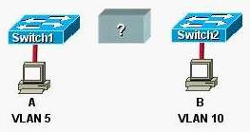
Figure No. 1

- Refer to the exhibit above in figure no. 1, what is required to communicate between host A and host B and why? [3 marks]
SW1(config)#int fa 0/13
SW1(config-if)#switchport port-security
SW1(config-if)# switchport port-security maximum 2
SW1(config-if)# switchport port-security mac-address sticky
SW1(config-if)#end

Figure No. 2

- Explain the commands shown in figure no. 2? [4 marks]
- What is the common method of configuring VLANs? Where are these VLAN information saved in the switch? [3 marks]
- When will you choose router instead of a layer 3 switch? [2 marks]

Question No. 2


Figure No. 3
- Compare the three modes shown in the switches in figure no. 3. [4.5 marks]
R1(config)#int f0/0.2
R1(config-subif)#encapsulation dot1q 20
R1(config-subif)#ip address 172.17.2.100 255.255.255.224
R1(config-subif)#end

Figure No. 4

- What is the VLAN number if a router subinterface is configured as shown in figure no. 4? And will a PC with the IP address of 172.17.2.125/26 have the following as its default gateway? Explain the 2nd line of the configuration? [4 marks]
- What are the common problems associated with VTP in a switched network? [3 marks]
- Referring to figure no. 3, if a VLAN is added at switch 1, what kind of messages will be passed by the switches shown and who will update the VLAN information? [3.5 marks]

Question No. 3

- An extended access list needs to be applied to a bracu router. What three pieces of information can be used in an extended access list to filter traffic? [2 marks]
- How are the lines of an Access Control List evaluated? As an ACL is evaluated, what happens when a parameter on the list matches an input? [3 marks]
- How do you decide to place standard and extended ACLs? [2 marks]

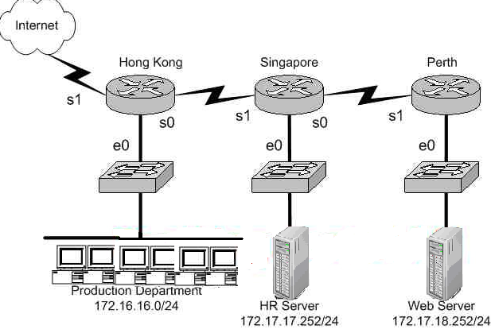
Figure No. 5

- Using figure no. 5, create a Named Extended Access List to prevent the production department 172.16.16.0/24 from accessing the HR server located at 172.17.17.252/24, but allow access to the web server via web. Where shall you place the ACL? [4 marks]
- Using figure no. 5, write another Named Extended ACL so that no one from the outside can access the production department and HR server but can access the web server. Where shall you place the ACL? [4 marks]

Question No. 4

- How can you configure a switch so that it does not win the election for Root Bridge? What does the command spanning-tree vlan 1 root secondary do? [3 marks]
- Name the Spanning-Tree states that the ports go through. And briefly state their functions. [4.5 marks]
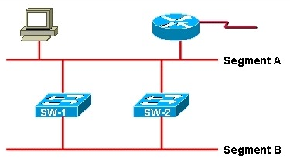
Figure No. 6

- In the above figure no. 6, the switched network suddenly went down, what are possible reasons? Explain briefly [4.5 marks]
- For which type of interfaces do we enable spanning-tree port fast and why? [3 marks]

Question No. 5

- How does PAT help in the NAT process? [3 marks]
- When a PC starts up how does the DHCP process helps it to acquire an IP address, list the steps. [3 marks]
- When a DHCP server in not in your own network, how will your broadcast request for an IP address reach the DHCP server? [2 marks]

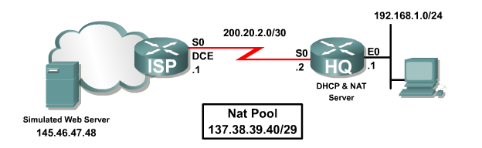
- Configure HQ with a NAT server to dynamically assign global outside IP addresses from the NAT pool 137.38.39.40/29 to local inside packets attempting to access the Internet as shown in figure no. 7. Any packet with an IP address from the 192.168.1.0/24 network will be translated. [4 marks]
Figure No. 7
- What commands are used to statically map the following private address to the public address using NAT, 10.0.0.10 / 24 and 141.46.47.48 / 28? [3 marks]

Question No. 6

Password: Poles
Password: Poles
East
West
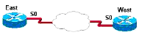
Figure No. 8
- Configure the East Router so that it can use PAP process to authenticate with the West Router as shown in figure no.8. [4 marks]
- In a point to point connection between two brac offices, which PPP subprotocol negotiates authentication options? What other options do they negotiate? [3 marks]
- Compare the two authentication process available in PPP. [3 marks]
- State some problems causing the output “Serial0/0 is up, line protocol is down”. [2 marks]
- What happens next when the router who sends the challenge packet receives the reply from the other router? [3 marks]

Question No. 7

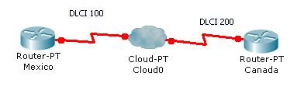
Figure No. 09
- The Frame Relay circuit between Mexico and Canada shown in figure no.09 is experiencing congestion. Which types of notification are used to alleviate the congestion? [4.5 marks]

Hong Kong# show running-config
<some output text omitted>
interface serial0/0
bandwidth 64
ip address 172.16.100.2 255.255.0.0
encapsulation frame-relay
frame-relay map ip 172.16.100.1 100 broadcast

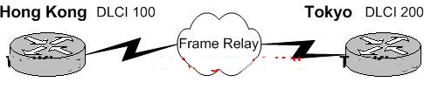
Figure No. 10

- The router Hong Kong is connected to the router Tokyo via a new Frame Relay link as shown in figure no. 10. However, Hong Kong is unable to communicate with Tokyo. Based on the above output, what do you suspect as the underlying cause of this problem? [3.5 marks]
- You are a technician at Netcom. Your newly appointed trainee is setting up a new frame relay connection to a remote branch and wants to know what the valid options for frame relay LMI types are. And are they compatible with each other. [3 marks]
- You are in the midst of configuring a router for a Frame Relay network. What could you do to prevent split horizon problems? [4 marks]

THE END

